

**END OF TERM ONE EXAMINATIONS 2023**

**BABY CLASS**

**LANGUAGE DEVELOPMENT ONE**

NAME_______________________________

1. Copy the same.

|  |  |  |  |  |
| --- | --- | --- | --- | --- |
|  |  |  |  |  |
|  |  |  |  |  |

1. Trace a table.
2. 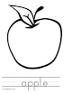Match the same.

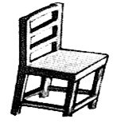







1. Colour the picture.

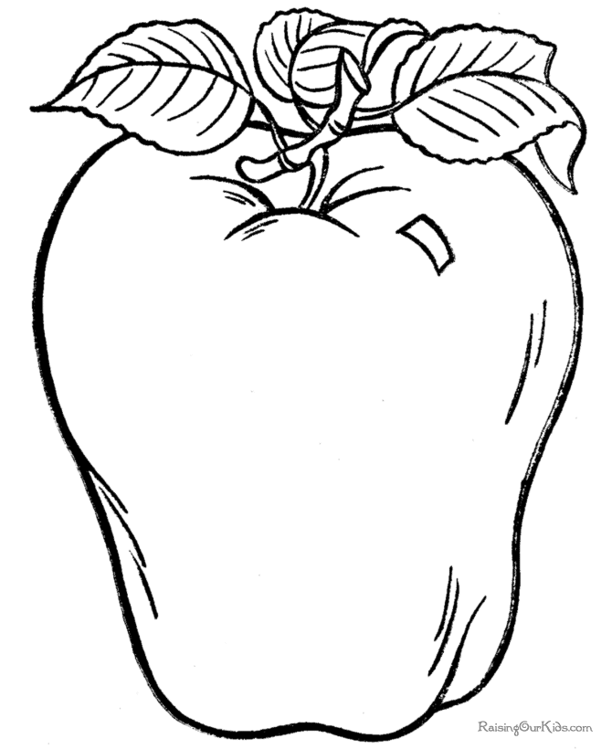

1. Join the dots.
2. Copy the same.

|  |  |  |  |  |
| --- | --- | --- | --- | --- |
| a | b | c | d | o |
|  |  |  |  |  |